Podman Setup Guide

1. Installation
Install Podman as a replacement for Docker, and Podman Compose as a replacement for Docker Compose. These tools allow container management and orchestration without requiring a daemon.
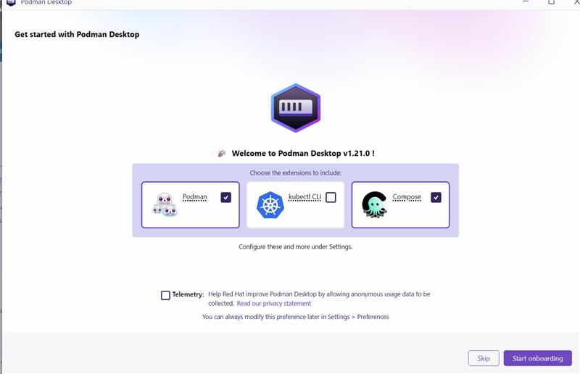

2. WSL Setup
Ensure Windows Subsystem for Linux (WSL) is installed and configured. WSL provides a Linux environment on Windows, which is essential for running Podman effectively.
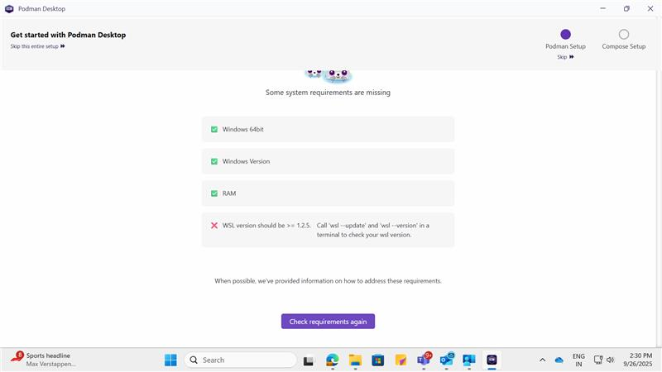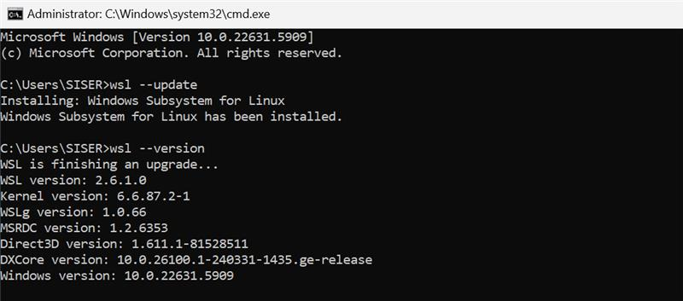

3. Docker Compatibility
Enable Docker compatibility mode in Podman. This allows Docker CLI commands to interact with Podman seamlessly.
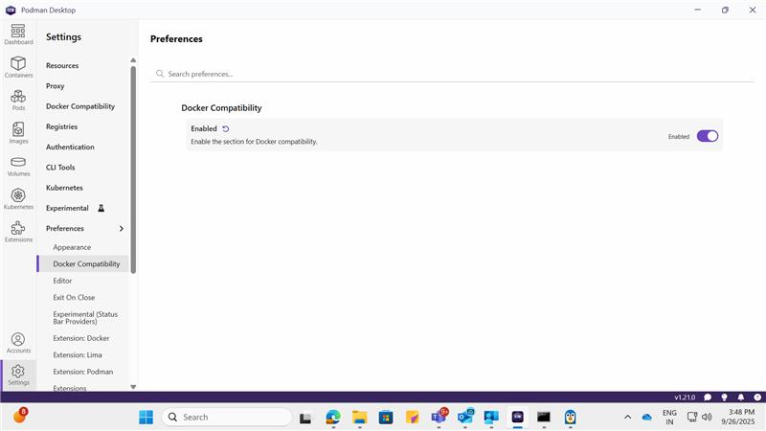
Change the Docker context to the one enabled by Podman. This ensures that Docker CLI communicates with Podman instead of Docker Engine.
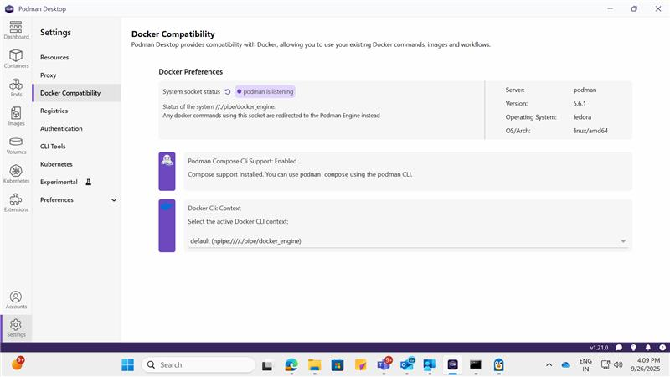

4. Docker CLI Configuration
Install Docker CLI without Docker Engine. This setup allows using Docker commands while relying on Podman as the backend.
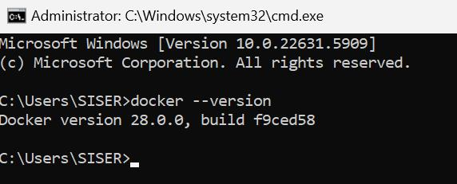
Verify that the Docker context is set to 'default' and points to 'npipe:////./pipe/docker_engine'. This named pipe is used by Podman to emulate Docker Engine.
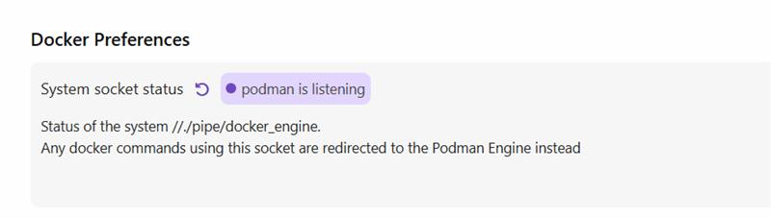
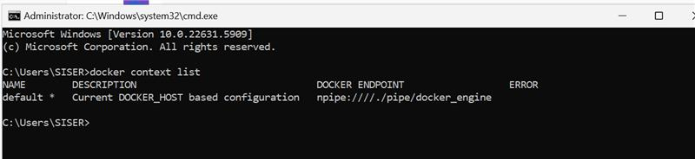
Confirm that Docker CLI is correctly pointing to the pipe. Although Docker Engine is not running, Podman listens on this pipe, allowing Docker CLI to function normally.
The output should show 'Server Version: 5.6.1' and 'Operating System: fedora', indicating that Podman is active.
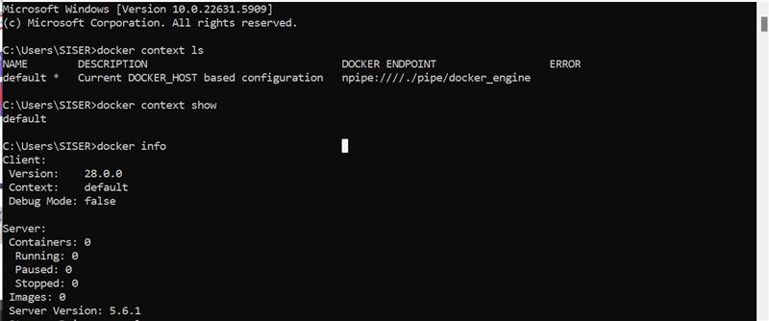
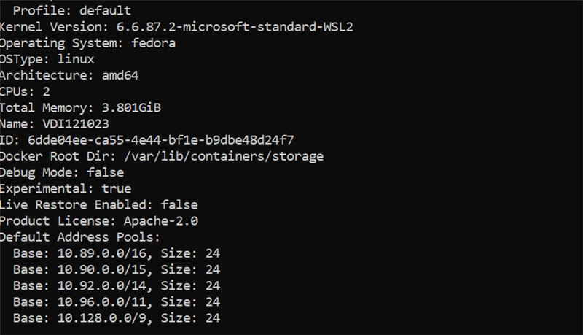

5. Pod Creation
Create a pod using Podman to group containers together. Pods allow shared networking and resource management among containers.
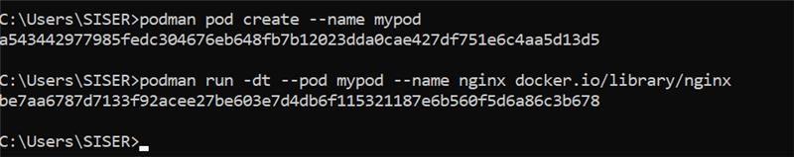

6. Notes and Considerations
- Podman does not use Docker Hub by default; it uses quay.io. However, you can specify docker.io/library/ngnix to pull images from Docker Hub.
- If quay.io is blocked by network security tools like Zscaler, configure Podman to use alternative registries or proxies.
6. Setting Docker Hub as Default Registry for Podman

developer-tools/docs/docker/podman-docker-hub.md at 40365ae8422fdc4615761a559401ab00364b39fe · hm-group/developer-tools

